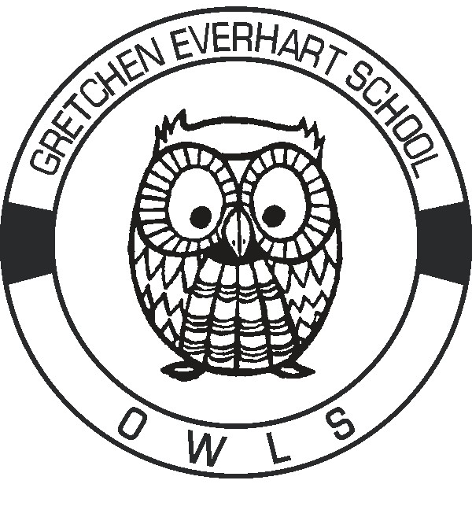**Gretchen Everhart School**

**Student Supply List 2023—2024**

**Below is a list of suggested items for each grade level to help make it a successful year**

**at Gretchen Everhart School!**

**Each student needs a backpack labeled with their name on it**

**Pre-K**

Facial Tissues (1) Individual wrapped snacks to share (14)

Baby Wipes (1) Mat for rest time

Washable Markers (1) Antibacterial Hand Soap (2)

Clorox Wipes (1)

**Elementary**

Antibacterial Hand Soap (2) Clorox Wipes (1)

Waterless Hand Sanitizer (1) Facial Tissues (2)

Quart Zip lock Bags (2) Elmer’s Glue Sticks (6)

Baby Wipes (1) Colored Dry Eraser Markers (1)

**Middle School**

Antibacterial Hand Soap (2) Baby Wipes (1)

Waterless Hand Sanitizer (1) Facial Tissues (2)

Quart Sized Ziploc Bags (1) Gallon Sized Ziploc Bags (1)

Elmer’s Glue Sticks (6) Clorox Wipes (1)

Colored Dry Eraser Markers (1)

**High School & Transition**

Colored Dry Eraser Markers (1) Baby Wipes (1)

Facial Tissues (1) Clorox Wipes (1)

Elmer’s Glue (2) Waterless Hand Sanitizer (1)

**Items that can always be used by all throughout the year:**

**Clorox Wipes (1)**  Antibacterial Hand Soap

**Baby Wipes**  Waterless Hand Sanitizer

Facial Tissues Zip Lock Bags

Paper Towels Edible reinforcers, fidgets

Walmart/Target gift cards for snacks and reinforcers